**Ref. No. CP43/10725**

**10 September, 2025**

**Proposal for College Chatbot for Enquiry Handling**

**Proposed to**

M. H. Saboo Siddik College of Engineering Byculla, Mumbai

**Proposed by**

# Er. Abdurrahman Qureshi

Project Manager

Dear Sir/Madam,

**Introduction**

Many students and parents need quick answers about admissions, courses, fees, and facilities. At present, answering all these enquiries takes a lot of staff time and sometimes delays the response.

To make this process faster and easier, we propose creating a chatbot for the college. The chatbot will act as a digital assistant that can answer common questions at any time of the day.

**Objectives**

* To build a simple chatbot for answering enquiries.
* To provide instant replies to frequently asked questions.
* To save staff time and reduce workload.
* To improve the experience of students, parents, and visitors.

**Methodology**

* **Step 1: Collect Information Data:** List the most common enquiries (admissions, courses, fees, facilities, contacts).
* **Step 2: Chatbot Design:** Create a question-and-answer database with clear replies.
* **Step 3: Integration:** Add the chatbot to the college website or app.
* **Step 4: Testing: Check if answers are correct and easy to understand.**
* **Step 5: Updates: Keep updating the chatbot with new information when required.**

**Timeline**

* **Week 1:** Collect requirements and plan content.
* **Week 2:** Design chatbot flow and prepare answers.
* **Week 3:** Develop and integrate the chatbot.
* **Week 4:** Testing and final launch.

**Expected Outcomes**

* Enquiries answered quickly, 24/7.
* Less workload for staff.
* Accurate and uniform information for all.
* A modern digital solution for the college.

**Budget**

* **Chatbot Design & Development:** Rs 1,50,000
* **Integration & Testing:** Rs 50,000
* **Annual Maintenance & Updates:** Rs 50,000
* **Total Estimated Cost:** Rs 2,50,000

**Conclusion**

This chatbot will make enquiry handling simple and effective. It will save time for staff and give students and parents the right information quickly.

We request your approval to begin this project. Sincerely,

# Er. Abdurrahman Qureshi

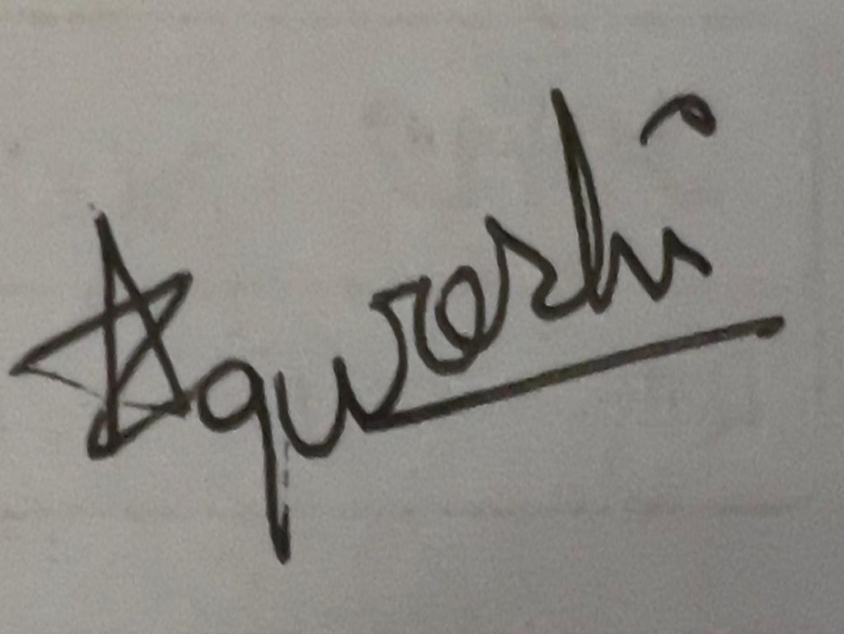

Project Manager